**Project Report On**

**REPORT CARD MANAGEMENT**

**ACKNOWLEDGEMENT**

Foremost of all,I express my sincere indebtedness to the “Almighty”, for bestowing me with all the favourable circumstances and kept me in high spirits,I am very great full to my advisor, Mr. Gaurav Goel for her patience,encouragement, and many fruitful discussions from the very early stage of this project. I would linke to thank, Dr. Manish Mahajan Head of Department of Computer Science and Engineering , Chandigarh Engineering College, Landran. I wish to express my appreciation to my family for my continuous love and encouragement, for always believing in me, for never failing to provide all the support, and for coping with the pressure that naturally comes with such endeavour.

**Introduction**

An important aid for teachers and students to judge their performance. First of all every teacher has its own login id and password. Teacher can see every student details and can edit it. Marks can be calculated by the teacher and can also edit it.This can be helpful for the teachers for calculating percentages and then automatically grades are displayed. Student performance in a particular subject or all the subjects must be expressed. And at last report card of whole class is generated.

**Goals :**

* This Will Help to Generate The Report Card of the student according to their Marks Very easily.
* Even the faculty can Generate the pdf report of the report card of students
* Every Class teacher can just see and edit the details of the student and their marks too.

**1.2 TECHNOLOGIES USED**

**1. JAVA:**

Java is an object-oriented programming language with a built-in application programming interface (API) that can handle graphics and user interfaces and that can be used to create applications or applets. Because of its rich set of API's, similar to Macintosh and Windows, and its platform independence, Java can also be thought of as a platform in itself. Much of the syntax of Java is the same as C and C++. One major difference is that Java does not have pointers.

Java applications are typically [compiled](http://en.wikipedia.org/wiki/Compiler) to [bytecode](http://en.wikipedia.org/wiki/Java_bytecode) that can run only on [Java virtual machine](http://en.wikipedia.org/wiki/Java_virtual_machine) (JVM) regardless of [computer architecture](http://en.wikipedia.org/wiki/Computer_architecture).

**1.1 JAVAFX**

Swing implements a set of GUI components that build on AWT technology and provide a pluggable look and feel. Swing is implemented entirely in the Java programming language, and is based on the JDK 1.1 Lightweight UI Framework.

Swing features include:

* All the features of AWT.
* 100% Pure Java certified versions of the existing AWT component set (Button, Scrollbar, Label, etc.).
* A rich set of higher-level components (such as tree view, list box, and tabbed panes).
* Pure Java design, no reliance on peers.
* Pluggable Look and Feel.

## 2.2. JDBC

The JDBC is a set of the database access classes. The term JDBC stands for "Java database Connectivity" and it was developed by Javasoft.

JDBC technology is an API (application program interface) that allows visual access to any tabular data source from java programming languages by mean of some connecting software called drives. It also provides access to other tabular data source such as spread sheets or flat files. The JDBC API allows developer to take advantage of the java platforms “write once, run anywhere" capabilities for industrial strings cross platforms applications that require access to enterprise data. The JDBC API is the industry standard for data base-independent connectivity’s between the java programming language and a wide range of the database. The JDBC API makes it possible to do these things

* Establish a connection with a database or access tabular data source.
* Send SQL statements and process the results.

**1.3. NETBEANS**

**NetBeans** is an [integrated development environment](https://en.wikipedia.org/wiki/Integrated_development_environment) (IDE) for [Java](https://en.wikipedia.org/wiki/Java_(programming_language)). NetBeans allows applications to be developed from a set of modular [software components](https://en.wikipedia.org/wiki/Software_component) called *modules*. NetBeans runs on [Microsoft Windows](https://en.wikipedia.org/wiki/Microsoft_Windows), [macOS](https://en.wikipedia.org/wiki/MacOS), [Linux](https://en.wikipedia.org/wiki/Linux) and [Solaris](https://en.wikipedia.org/wiki/Solaris_(operating_system)). In addition to Java development, it has extensions for other languages like [PHP](https://en.wikipedia.org/wiki/PHP), [C](https://en.wikipedia.org/wiki/C_(programming_language)), [C++](https://en.wikipedia.org/wiki/C%2B%2B), [HTML5](https://en.wikipedia.org/wiki/HTML5),, and [Javascript](https://en.wikipedia.org/wiki/JavaScript). Applications based on NetBeans, including the NetBeans IDE, can be extended by [third party developers](https://en.wikipedia.org/wiki/Third_party_developer). NetBeans began in 1996 as Xelfi a Java IDE student project under the guidance of the Faculty of Mathematics and Physics at [Charles University](https://en.wikipedia.org/wiki/Charles_University) in [Prague](https://en.wikipedia.org/wiki/Prague). In 1997, Roman Staněk formed a company around the project and produced commercial versions of the NetBeans IDE until it was bought by [Sun Microsystems](https://en.wikipedia.org/wiki/Sun_Microsystems) in 1999.

1. **DATABASE : MySQL**

MySQL is a relational database management system (RDBMS), and ships with no GUI tools to administer MySQL databases or manage data contained within the databases. Users may use the included command line tools, or use MySQL "front-ends", desktop software and web applications that create and manage MySQL databases, build database structures, back up data, inspect status, and work with data records. It is named after co-founder Michael Widenius's daughter, My.SQL stands for structured query language, better known as "sequel".

**PROJECT**

**2.1. OVERVIEW OF PROJECT:**

This project on **STUDENT REPORT CARD GENERATOR** has student class with data members:

* roll no,
* Name
* Marks
* Fathers name
* Disability
* Address
* Phone no
* Class
* Section

Member functions in this class are used to display :

* Details of students
* Teacher can edit marks of the student
* A function to calculate grade based on marks obtained by student

An important aid for teachers and students to judge their performance. First of all every teacher has its own login id and password. Teacher can see every student details and can edit it. Marks can be calculated by the teacher and can also edit it.This can be helpful for the teachers for calculating percentages and then automatically grades are displayed. Student performance in a particular subject or all the subjects must be expressed. And at last report card of whole class is generated.

PURPOSE OF THIS PROJECT

* In a school or college, we give papers and get different marks from different subjects and for that purpose we need a file to store our record and also some functions to calculate percentage and grades. This student report card constitutes of all these things.
* The purpose of storing and maintaining student’s curricular record for better use and efficient work we use student report card.

**PROJECT SNAPSHOTS**

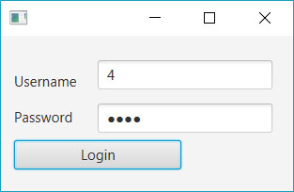

Login Module

This is the first module of my project,Login . On entering the correct password and then clicking on the Login button, After filling the user id and password you need to click on the login button. If the record matches the records in the database then this will open in front of you otherwise a dialog box showing a sorry message will appear. A new module opens. In the new module there appears three buttons:

* VIEW DETAILS:this will appear all the details of student after entering class,section and roll no
* EDIT MARKS:In this teacher can edit marks of the student
* GENERATE CARD:On clicking this button this will generate a PDF of report card of all the students.

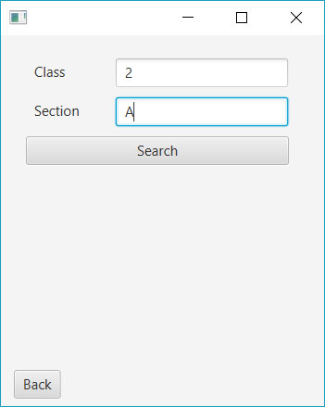

Now,After clicking on view details a new module will open,in which after entering correct class,section and roll no as shown in fig.2.3 it will appear all the details of that student that includes:Name,Class,Roll no,Fathers Name,Contact no,Address,Blood Group,Caregory and Disability as shown in fig.2.4

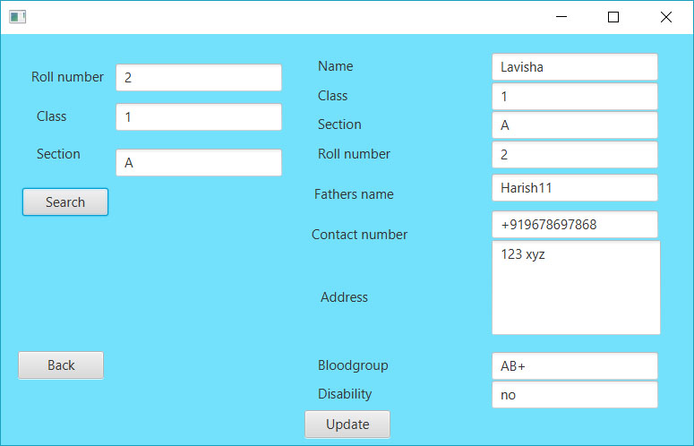

Then if we go on to the next button and i.e.Edit marks,in this teacher can edit marks of any student by entering the correct class and section as shown

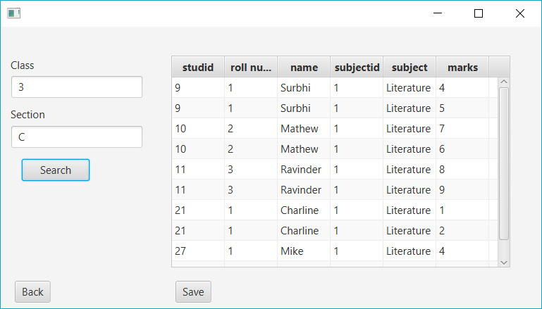

And after clicking on SUBMIT button a new window will appear as shown

This window will display only that particular subjects and marks that one teacher taught and rest of the subjects are disabled. If login id and password is changed then subjects also changed.By clicking on SAVE button,it will save all the changes that a teacher has changed.

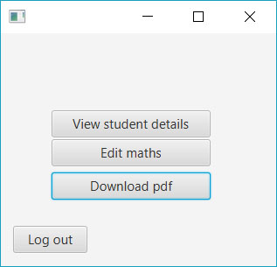And at last by clicking on generate PDF, it will generate a pdf of all the students with percentage and grades.